301 Fall 2025

Second Writing Assignment
The second paper should have the following sections and follow APA manuscript style (see professional-annotated.pdf for an outline).
- Abstract
- Introduction
- Experiment 1
  - Methods, with subsections
  - Results, Figure 1
  - Brief Discussion (transition to Experiment 2), 1 paragraph
- Experiment 2
  - Methods, with subsections, Figure 2
  - Results, Figure 3
- General Discussion
- References

Guidance on expanding the Introduction and Discussion
The Introduction should still cite Craik & Lockhart (1972) to introduce the theory of why deeper encoding is hypothesized to lead to better memory or the Craik (2002) more recent review of the theoretical idea. Data from specific experiments within Craik & Tulving (1975) should be described to support the theory. Motivate the studies being presented by identifying similarities and differences between our two experiments and that paper. Emphasize what is new about our study that adds to the broader theoretical idea.
Additional publications, Baddeley & Hitch (2017) and Ovalle-Fresa, Uslu & Rothen (2021), have been made available with the experimental data for this study so that you can use this publication to provide additional support your report of our in-class experiment. The research presented in that paper is based on the same theoretical ideas as our study, but uses slightly different operational definitions of the dependent variable (different methods of measuring memory) and stimuli.
The General Discussion section should review the results of the overall findings with consideration of both Experiment 1 and Experiment 2. Reference to specific numbers reflecting performance of specific groups/conditions are generally not needed in this section. Reference to t-values, F-rations or p-values are never included in the Discussion. Connect the results back to the theoretical ideas you described in the Introduction. Identify applications of the findings outside the laboratory. Consider any limitations of the study where definitions or procedures were potentially imperfect. Note that problems that might have simply increased variance/noise are not limitations. Those would make it harder to get a significant, reliable finding and we already know those. Use the other published reports to help address limitations where appropriate. Note that acknowledging a potential problem does not mean the study is fatally flawed, just that additional work might address that concern in the future. End on a positive note.
The abstract should be about 200 words and summarize the entire paper including the theoretical ideas, findings from both experiments and conclusions. Recommendation is to write this section last, but still put it first (after title page).

Experiment 2 Methods
The following provides the information you will need regarding the participants, materials (stimuli) and procedure for reporting on Experiment 2. The information is not presented in a manner that can be cut and pasted into your second paper. Edit the given values into sentences in the appropriate sections.

Participants
- Two sections of Research Methods recruited participants
- 132 participants provided data. Age and gender of the participants was not provided by the participants.

Stimuli
Some examples of image stimuli to use for making Figure 2 to illustrate the methods for Experiment 2.

Meaningful object stimuli and similar lure items for the forced-choice recognition task:
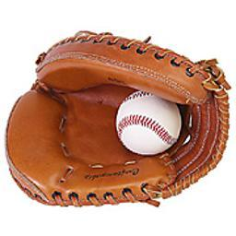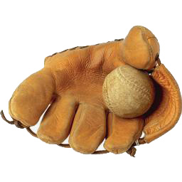
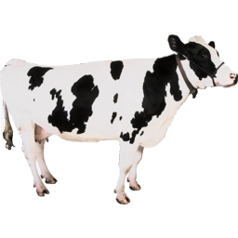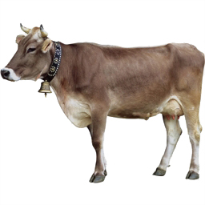

Abstract stimuli and novel items used for a similar forced-choice recognition task:



Procedure
Instructions:
“For each picture, indicate which colors of the five listed below are most prominent in the image. Indicate your rating with keyboard or mouse.”
1 = black or gray, 2 = red or brown, 3 = blue or purple, 4 = green or pink, 5 = yellow or white
“For each picture, rate how much you like the image on a 1 to 5 scale. 5 means you like the image very much and 1 means you dislike the image very much. Indicate your rating with keyboard or mouse.”
1 = dislike a lot, 2 = dislike a little, 3 = neutral, 4 = like a little, 5 = like a lot
Images were on screen for rating for up to 4 seconds (both conditions).

40 images were shown during study
At test, each image was shown together with a similar new image.
The instructions were:
“Next is a recognition test. Two images will be shown together. Either the left or right one was seen in the first part. 'Choose which one you think it is.”
Participants had as much time as they needed to make their recognition memory response.

